Exp No:3.a
Conduct an experiment to show data visualization using line plot

code
import matplotlib.pyplot as cricket
Overs=list(range(5,51,5))
Indian Score [30,55,90,129,165,200,239,270,310,350]
Srilankan Score [25,70,90,120,140,170,195,220,255,279]
cricket.plot(Overs, Indian_Score)
cricket.plot(Overs, Srilankan_Score)
cricket.show
cricket.title ("INDIA Vs SRILANKA")
cricket.xlabel("Overs")
cricket.ylabel("Score")
cricket.legend()
cricket.plot(Overs, Indian_Score, color="green", label="INDIA")
cricket.plot(Overs, Srilankan_Score,color="red", label="SRILANKA")
cricket.legend(loc="center right")
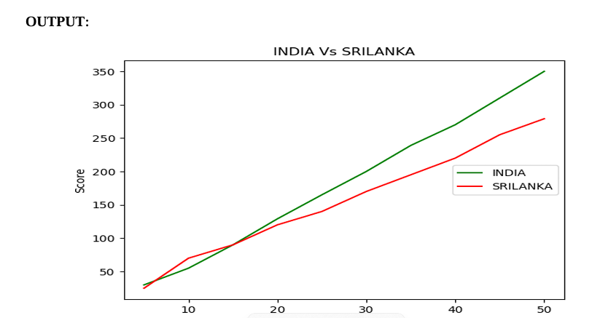

Exp no 3 b
Conduct an experiment to show data visualization using bar chart

code
import matplotlib.pyplot as hscmark
import numpy as np
Names = ['SHREE', 'DEV', 'KEERTHI', 'PRIYA', 'SHAN', 'KUMARAN']\
xaxis np.arange(len(Names))
Percentage_hsc = [96, 91, 94, 75, 45, 81]
hscmark.bar(Names, Percentage_hsc)
hscmark.xticks(xaxis, Names, rotation=45)
hscmark.xlabel("Names of Pupil")
hscmark.ylabel("Percentage")
hscmark.title("Comparison of HSC Percentage", fontsize=20, color="green")
hscmark.show()

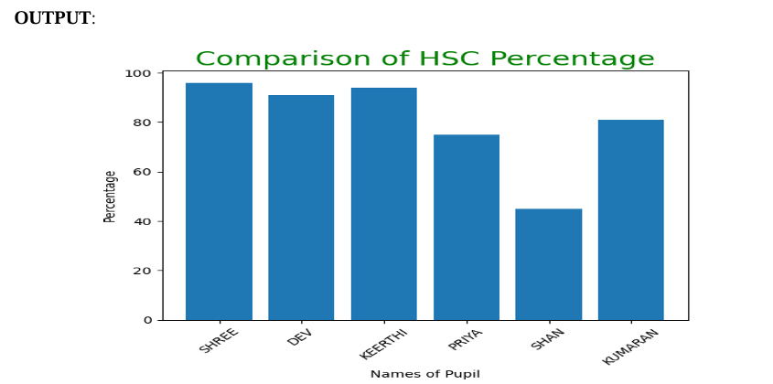

Exp No:3.c
Conduct an experiment to show data visualization using pie chart

CODE
import matplotlib.pyplot as election
labels = ['CANDIDATE 1', 'CANDIDATE 2', 'CANDIDATE 3', 'CANDIDATE 4']
Votes = [315, 130, 245, 210]
colors = ['green', 'yellow', 'red', 'orange']
explode = (0.2, 0, 0, 0)
election.pie(Votes, labels=labels, colors=colors, explode=explode, autopct="%0.2f% %")
election.title('Election Results')
election.show()
